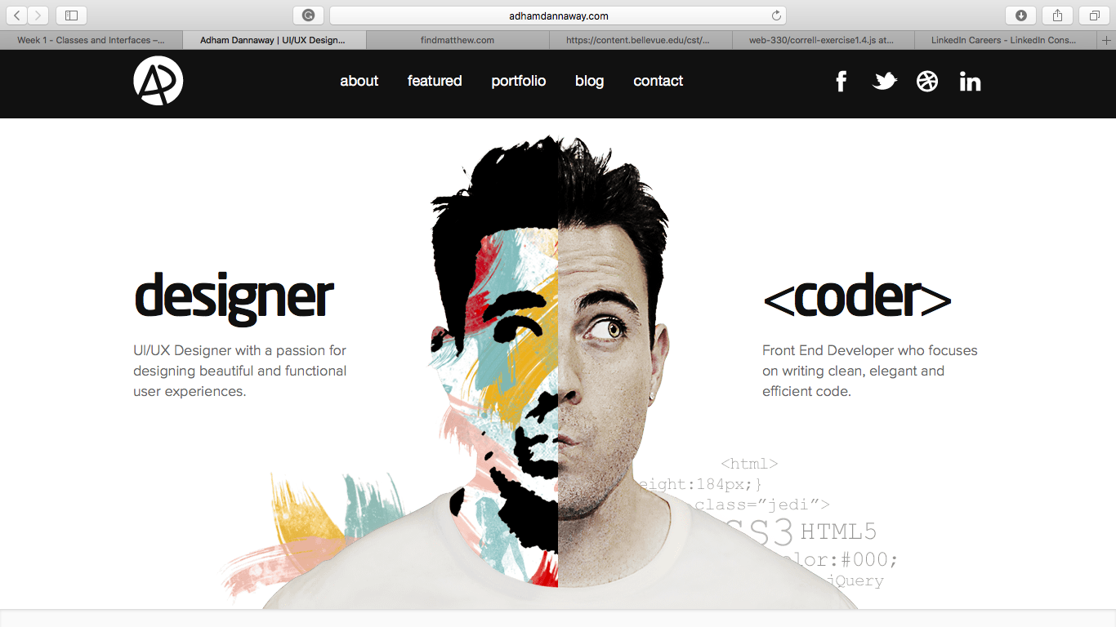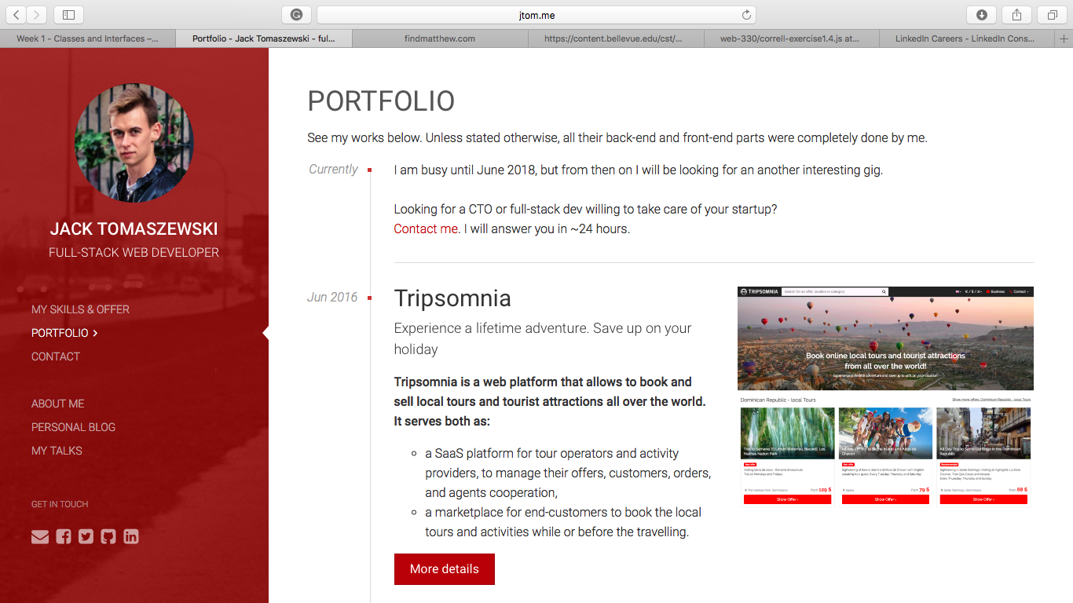This design does a nice job of showcasing his design skills and his projects. As you scroll down, all of his work is displayed with a screenshot of the homepage and a brief description. The drawback to this design is that it is not particularly interactive. From just looking at his page, and not his work, I wouldn’t be excited about hiring him to by my web developer.

This portfolio is really cool. This is the above fold screenshot and as you scroll down he has links to some of his latest work. If you move your mouse over the designer side of the page, the picture also moves to reveal the full artwork and as you move to the code side, the rest of that picture appears. The design is clean and simple but even in its simplicity you can see he has great design skills. A drawback to this design is if somebody is quickly looking for somebody who can do a specific thing, they will have to dig a little deeper into his portfolio.

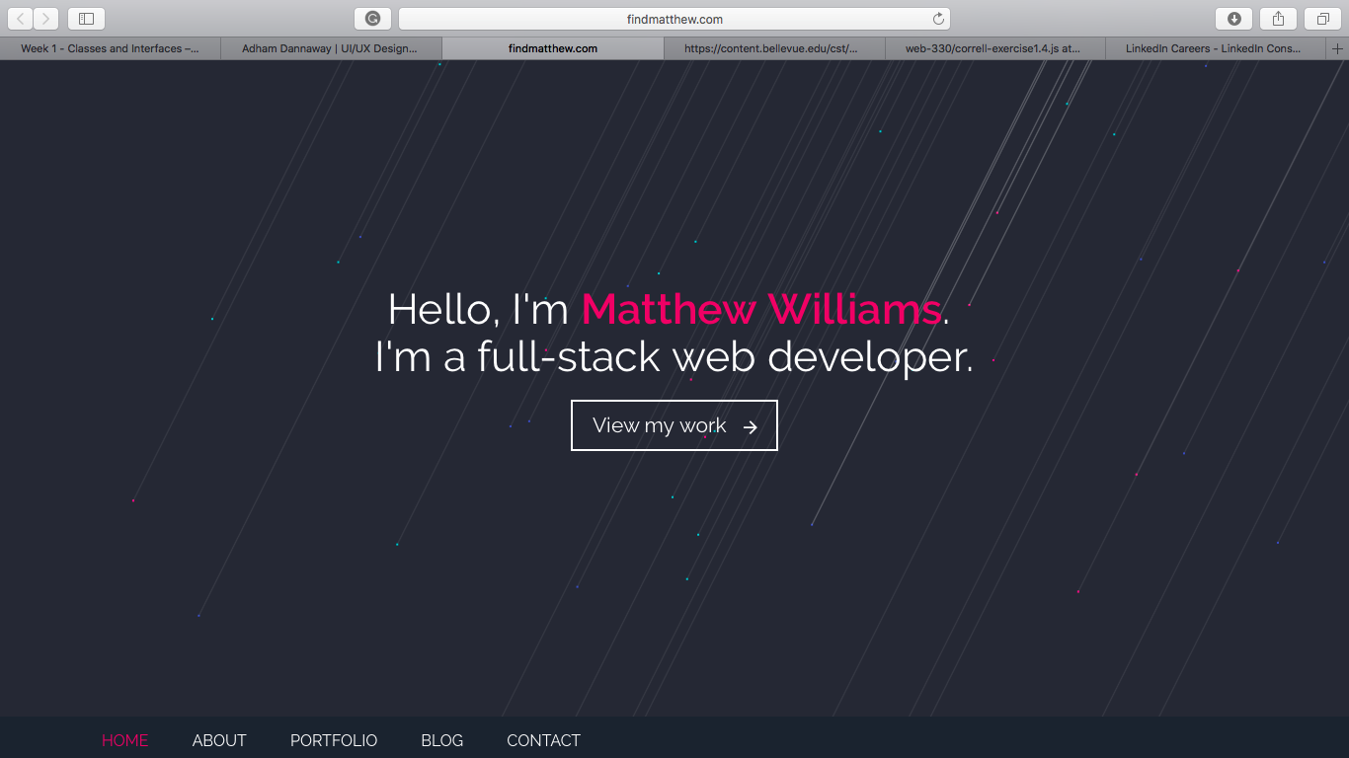This portfolio is cool because this is the above fold and if you click the view my work button it scrolls down to his latest work and outlines his skillset. The lines are also animated. They move around to look like spotlights shining on the ground which is simple but does a good job of showcasing the work he can do. One odd thing about his site though is the placement of the navigation bar at the bottom of the page. I didn’t even notice it was there until I scrolled back up the page.